THUNDER CLIENT
MUPPARAPU GANESH KUMAR
2303A51358
B-20

CODE:
const express = require("express");
const app = express();

app.use(express.json());

let books = [
{ id: 1, name: "Java", price: 500 },
{ id: 2, name: "Python", price: 600 }
];

// GET all books
app.get("/books", (req, res) => {
res.json(books);
});

// GET single book
app.get("/books/:id", (req, res) => {
const book = books.find(b => b.id == req.params.id);

if (!book) return res.status(404).send("Book not found");

res.json(book);
});

// ADD book
app.post("/books", (req, res) => {
const newBook = {
id: books.length + 1,
name: req.body.name,
price: req.body.price
};

books.push(newBook);
res.send("Book added successfully");
});

// UPDATE book
app.put("/books/:id", (req, res) => {
const book = books.find(b => b.id == req.params.id);

if (!book) return res.status(404).send("Book not found");

book.name = req.body.name;
book.price = req.body.price;

res.send("Book updated successfully");
});

// DELETE book
app.delete("/books/:id", (req, res) => {
books = books.filter(b => b.id != req.params.id);
res.send("Book deleted successfully");
});

// 🔥 PORT 3000
app.listen(3000, () => {
console.log("Server running on http://localhost:3000");
});
server:
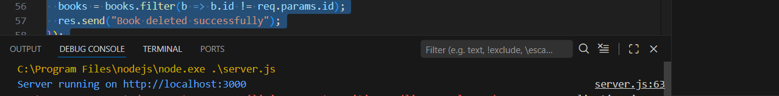
OUTPUT:
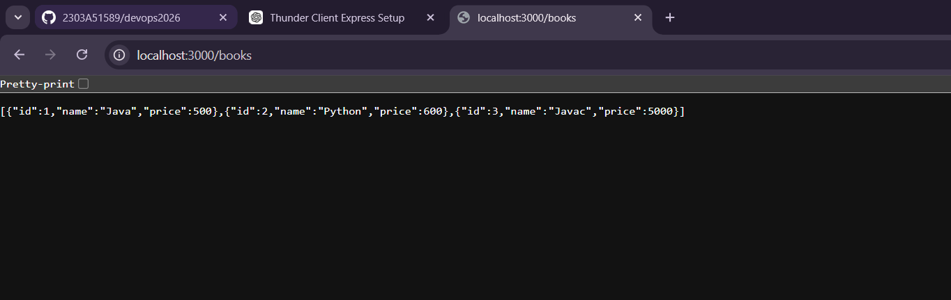
POST OPERATIONS:
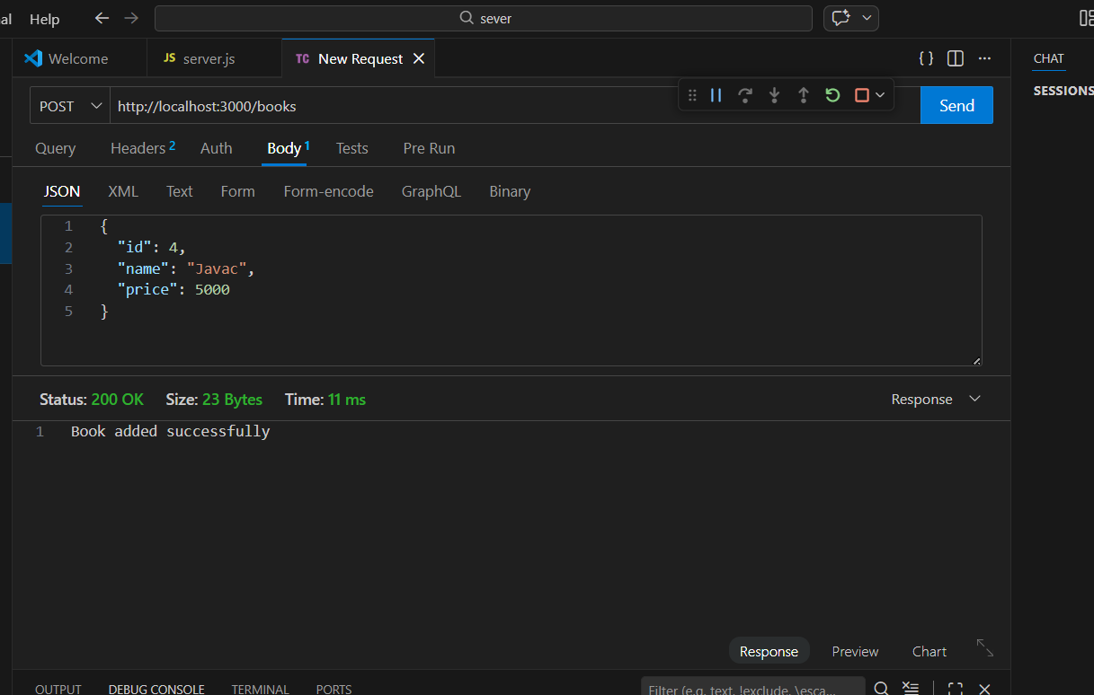
DELETE OPERATIONS:
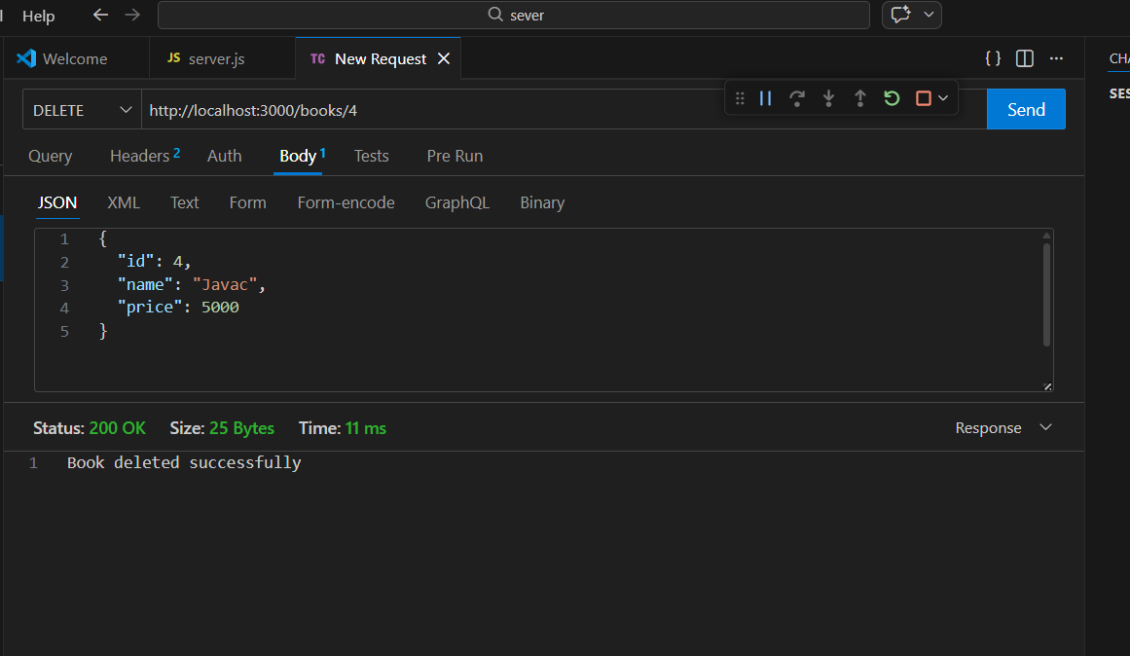
OUTPUT:
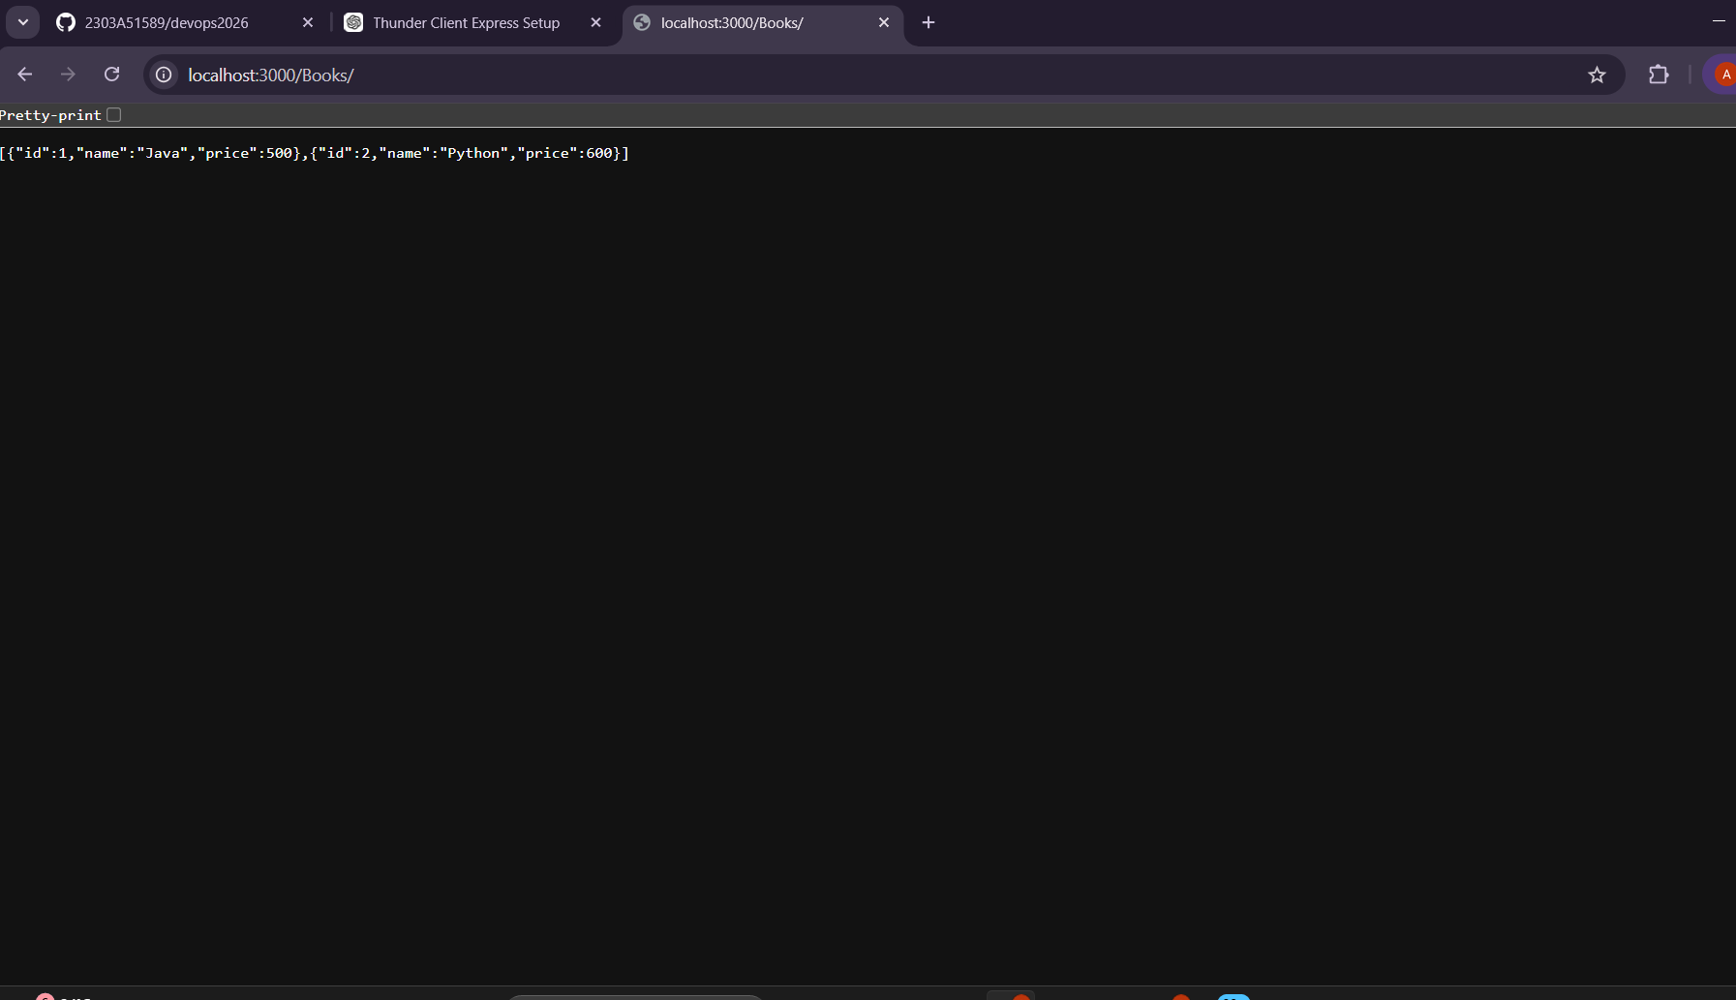
GET OPERATION:
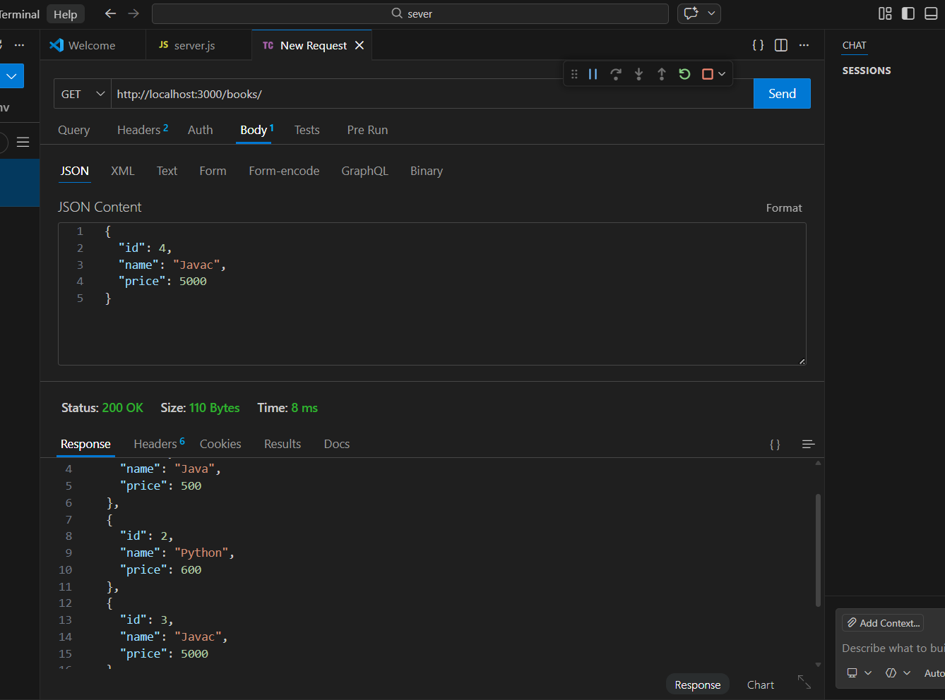
OUTPUT:
